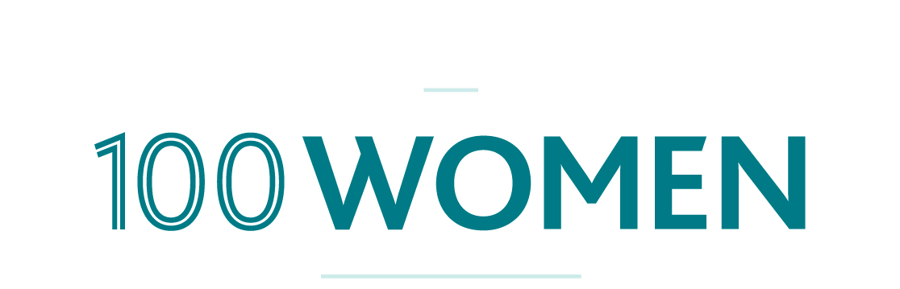

Please find below a short (and slightly longer) newsletter blurb regarding 100 Women. If you would like to know more please contact us via info@100women.com.au or by calling Megan Anderson (Vice Chair) on 0408 917 196.

VERSION 1:
100 Women is Perth’s newest giving circle, working to ignite women’s philanthropy and enable everyday people to be involved in creating a world where all women and girls can live safely with access to health, education and economic freedom. We do this by combining donations and knowledge to provide impactful grants.
Since launching at the end of March, we have raised more than $95,000, but our aim is to give away $120000 in grants before the end of the year and we have set ourselves the ambitious goal of bringing together 20 more members before the 10th November 2014.
If you would like to know more about getting involved, supporting the organisation or become a member, please visit our website: 100women.com.au, or join us on Facebook.

VERSION 2: (continues on page 2)
100 Women is Perth’s newest giving circle, working to ignite women’s philanthropy and enable everyday people to be involved in creating a world where all women and girls can live safely with access to health, education and economic freedom. We do this by combining donations and knowledge to provide impactful grants.
Since launching at the end of March, we have raised more than $95000, and we have set ourselves the ambitious goal of bringing together 100 members by 10th November.
The organisation has launched in response to the needs of women across the globe and is unique because we believe support is more meaningful and more powerful when donors have the opportunity to meet, talk with and support recipients.
Everyone is welcome to join and by coming together collectively we can exponentially increase the value of individual donations to bring about real and significant change.
100 Women is calling on all the courageous and determined women to join the movement and be the positive change they want to see in the world.
Our membership is a fully tax deductible donation of $1200 (which can be paid in a lump sum, or by a payment plan), which will allow us to give away $120000 in grants before the end of the year.
If you would like to know more about getting involved, supporting the organisation or become a member, please visit our website: 100women.com.au, or join us on Facebook.
We would love for you to share the message of 100 women with your network.

